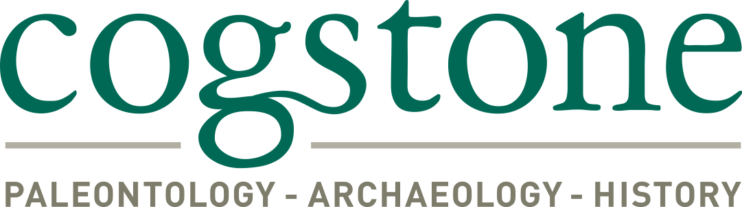
Janell Mort
Archaeologist and Cross-trained Paleontologist

Education
2011 M. A., Anthropology, California State University, Fullerton
2004 B. A., Anthropology, California State University, Fullerton

Summary Qualifications
Ms. Mort is a qualified archaeologist and cross-trained paleontologist. She has over ten years of experience performing monitoring, surveys, testing, archaeological data recovery, fossil recovery, general lab work and fossil preparation. She has more than 100 hours of company-paid training in paleontology and archaeology. In addition she is 40-hr HAZWOPER certified.

Selected Projects
High Desert Corridor/ SR 138 Widening Project, FHWA/Caltrans District 7, Los Angeles and San Bernardino Counties, CA. The project involves construction of a new, approximately 63-mile long, east-west freeway/expressway between SR 14 in Los Angeles County and SR 18 in San Bernardino County. Field pedestrian survey for Extended Phase I (XPI) Testing, subsurface testing of four archaeological sites in the Area of Potential Effects (APE), and lab work. Caltrans is the lead federal and state agency; compliance with Section 106 and CEQA required. Sub to Parsons Transportation Group. Archaeology Technician. 2014-2015
Caltrans District 6 On-Call, Merced, Madera, Tulare, Kings, and Kern Counties, CA. Paleontology Monitor. Multiple task orders, under subcontract to URS Corporation, including: monitoring for the Arboleda Drive Freeway Project, State Route 99, in Merced County (including field testing and microfossil sorting); monitoring a for the State Route 41 Rehabilitation Project near Kettleman City in Kings County, CA.; monitoring for the Bradley Overhead Replacement along State Route 140, in Merced County, CA; and monitoring for the Savage Way Rehabilitation, east of Stockton. 2011-2012

Perris Valley Line, Metrolink, Riverside County Transportation Commission, Riverside County, CA. The project is a 24-mile extension of the Metrolink 91 Line. Conducting paleontological and archaeological monitoring for construction of four new stations, upgrading associated track and utility relocations to extend the Metrolink connection from Riverside through Moreno Valley to Perris. Sub to HDR Engineering. Field Technician. 2013-2016
Exposition Light Rail Phase 2, Exposition Transit Authority, Los Angeles County Metropolitan Transportation Authority, sub to URS Corporation, Culver City to Santa Monica. The 6.6-mile second phase involves construction and installation of tracks, grade separations, seven new stations and associated facilities. Currently conducting monitoring of construction activities in multiple locations along the project ROW. Coordinate with construction work crews and inspectors, conducted awareness training, provide daily reporting, recovering artifacts related to the historic rail line and documenting historic rail line features. Paleontology/ Archaeology Monitor. 2012-2015

WECC Path 42 Transmission Line Upgrades, Southern California Edison, Palm Springs area, Riverside County, CA. Conducted survey and mitigation monitoring during construction for a 14.5 mile transmission line segment on BLM and private lands. Archaeology Technician. 2014-2015

Fogarty Substation, Southern California Edison, Riverside County, CA. Performed archaeological and paleontological monitoring during ground disturbing activities in Lake Elsinore. Recovered fossils. Archaeological/Paleontological Monitor. 2014

Devers-Mirage 115 KV System Split, Southern California Edison, Palm Springs area, Riverside County, CA. The project involved electrical systems facilities upgrades in Cathedral City, Indian Wells, Palm Desert, Palm Springs, Rancho Mirage, Thousand Palms and unincorporated Riverside County. Paleontology Monitor. 2011-2012

